Epsom & Ewell F.C.
20
v
Hanworth Villa
Tuesday, 3rd March 2015
For our league match this evening we welcome the players and officials of Hanworth Villa along with today's match officials and of course our own regular supporters.

We also welcome back former Epsom legend Dale Marvell, one of only twelve players to make three hundred appearances for our club. Kyle Hough would have become the thirteenth member of that elite group this very evening, had it not been for our trip to Molesey being postponed on Saturday. We’ll just have to wait a few more days!

Our opponents have had a very difficult season, and we didn’t help them with a 5-2 win at the Ranch back in September. Things have improved recently but a number of late goals have left them in a desperate fight for survival; one that I don’t expect many people saw coming.

The big uncertainty every season is whether three clubs will actually go down from our division. It happened last year, but that was the first time in quite a while and I don’t see it occurring this time. With the F.A. insistence on a guaranteed relegation, at least one club will go and for what it’s worth I hope Hanworth stay up.

For us, this is a massive banana skin game. Tonight’s League match is the first we have played against a team in the lower half of the table since early November, a run of 15 games. Throw in two cup games with Camberley and another with Molesey and only our League Cup trip to Frimley Green has been what you might call an easier fixture on paper.

This is why it is very important that we treat tonight’s fixture in the same way that we have against all the recent opponents we have faced. Every game is competitive at this level and although our own League position appears secure, you have to keep it that way by defeating at the very least, those clubs that are below you.

We were last here for a bizarre League Cup match where we led Camberley Town 2-0 at half time and could have been four or five up at the break, such was our dominance. How this game got away from us I’ll never know, but conceding four to lose the match from such a strong position was a real shock. Following tonight’s game we host Cove on Saturday and just for the record our trip to Molesey is now scedhuled for Wednesday 8th April.

We are urgently looking for match and player sponsors, please get in touch! Also, the Salts Super Six Predictor jackpot is now up to £306 just for getting six results right. How much larger can that prize get?

Thanks for watching today. Glyn, the lads and the club value your support.

Rich

Cover photo this week by Colin Evans

Sam Robinson opens the scoring at Rectory Meadow on Saturday 06/09/14 with a diving header, setting us on our way to a 5-2 win

Cherry Red Records
Combined Counties League
Premier Division Table 2014/15
inc Saturday  28th February 2015 | P | W | D | L | F | A | Pts | GD | H | A
Cove | 31 | 22 | 5 | 4 | 76 | 46 | 71 | +30 | 7/3 | 0-1
Camberley Town | 29 | 21 | 5 | 3 | 70 | 21 | 68 | +49 | 2-4 | 0-1
Molesey | 26 | 20 | 0 | 6 | 76 | 25 | 60 | +51 | 1-3 | 8/4
Ashford Town (Mx) | 29 | 19 | 3 | 7 | 72 | 37 | 60 | +35 | 2-4 | 3-1
Windsor | 31 | 18 | 4 | 9 | 71 | 42 | 58 | +29 | 0-5 | 11/4
Spelthorne Sports | 29 | 16 | 3 | 10 | 60 | 48 | 51 | +12 | 4-3 | 3-0
Badshot Lea | 28 | 13 | 5 | 10 | 60 | 46 | 44 | +14 | 21/3 | 2-4
Hartley Wintney | 30 | 13 | 4 | 13 | 41 | 55 | 43 | -14 | 2-1 | 1-2
Farnham Town | 28 | 12 | 5 | 11 | 64 | 64 | 41 | 0 | 2-4 | 2-0
Bedfont Sports | 29 | 12 | 3 | 14 | 45 | 52 | 39 | -7 | 0-1 | 2-0
Colliers Wood United | 29 | 11 | 3 | 15 | 51 | 53 | 36 | -2 | 4/4 | 2-3
Epsom & Ewell | 27 | 11 | 2 | 14 | 50 | 52 | 35 | -2 | - | -
Mole Valley SCR | 28 | 10 | 5 | 13 | 50 | 69 | 35 | -19 | 1-0 | 5-2
Chertsey Town | 31 | 10 | 4 | 17 | 50 | 70 | 34 | -20 | 1-2 | 14/3
Raynes Park Vale | 25 | 8 | 5 | 12 | 34 | 44 | 29 | -10 | 0-1 | 10/3
Knaphill | 29 | 8 | 5 | 16 | 37 | 65 | 29 | -28 | 18/4 | 4-1
Westfield | 26 | 7 | 6 | 13 | 37 | 49 | 27 | -12 | 24/3 | 0-4
Horley Town | 28 | 6 | 7 | 15 | 53 | 76 | 25 | -23 | 2-2 | 6/4
Hanworth Villa | 27 | 6 | 5 | 16 | 39 | 57 | 23 | -18 | 3/3 | 5-2
Frimley Green | 30 | 6 | 4 | 20 | 46 | 79 | 22 | -33 | 0-0 | 25/4
Guildford City | 26 | 6 | 3 | 17 | 44 | 76 | 21 | -32 | 4-1 | 28/3

Lucky Day? - 3rd March
Played 12- Won 6 Drawn 2 Lost 3 Abandoned 1
F 26 A 19 - PPG 1.82 - Good
Club record against Hanworth Villa
Played 11 - Won 5 Drawn 2 Lost 4 - F 25 A 21 - PPG 1.55 - Above Average
Last visit
Saturday, 26th April 2014 - Lost 1-4 - Combined Counties League

Results and Fixtures
Combined Counties League Cup QF – Tuesday 24th February
Epsom & Ewell | 2-4 | Camberley Town
Combined Counties League – Saturday 28th February
Ashford Town (Mx) | 3-3 | Horley Town
Badshot Lea | 4-1 | Chertsey Town
Bedfont Sports | 1-3 | Spelthorne Sports
Camberley Town | 0-0 | Westfield
Cove | 3-1 | Knaphill
Frimley Green | 2-0 | Windsor
Hanworth Villa | 4-1 | Hartley Wintney
Combined Counties League Cup QF – Tuesday 3rd March
Farnham Town | V | Cove
Surrey Senior Cup QF – Tuesday 3rd March
Molesey | V | Badshot Lea
Combined Counties League – Tuesday 3rd March
Epsom & Ewell | V | Hanworth Villa
Mole Valley SCR | V | Camberley Town
Raynes Park Vale | V | Guildford City
Spelthorne Sports | V | Hartley Wintney
Westfield | V | Colliers Wood United
Combined Counties League – Saturday 7th March
Chertsey Town | V | Farnham Town
Epsom & Ewell | V | Cove
Guildford City | V | Ashford Town (Mx)
Hanworth Villa | V | Windsor
Horley Town | V | Westfield
Knaphill | V | Bedfont Sports
Mole Valley SCR | V | Frimley Green
Molesey | V | Badshot Lea
Raynes Park Vale | V | Camberley Town
Spelthorne Sports | V | Colliers Wood United
Surrey Senior Cup SF – Tuesday 10th March
Merstham | V | Ashford Town (Mx)
Combined Counties League – Tuesday 10th March
Badshot Lea | V | Hanworth Villa
Hartley Wintney | V | Guildford City
Mole Valley SCR | V | Farnham Town
Molesey | V | Cove
Raynes Park Vale | V | Epsom & Ewell
Spelthorne Sports | V | Windsor
Westfield | V | Camberley Town

From behind the goal
Epsom & Ewell 2-4 Camberley Town
Combined Counties League Cup - Quarter Final - Tuesday 24th February 2015

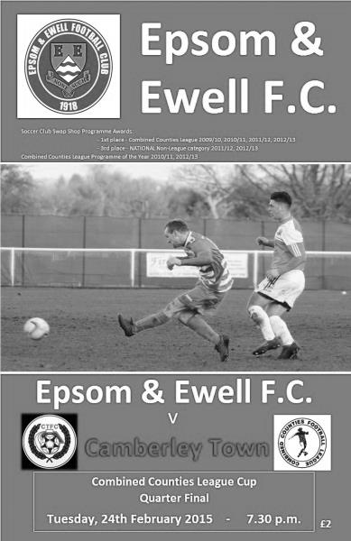
Salts fail to take golden opportunity

46 people were present to witness the strangest game of Epsom's season so far with six goals, all at the far end of the ground, in a match containing two periods of football that were so completely polarised in terms of possession that even the old cliché " a game of two halves" doesn't properly do it justice.

We had a number of players in the team who hadn't been available for one reason or another in the recent League match as Kyle Hough was present, as were Sam Robinson and Dan Dean. For Camberley, their big threat in that League match, James Hubbard was suspended so on paper, it looked as though we had every chance of upsetting the form book in this Quarter Final.

And that's how it looked early on as we flew out of the blocks and led with just seventy five seconds on the clock. Matt Farrell, playing in an advanced role, got down the right wing and had acres of space to find Hough with a low ball and he had time to control it and pick his spot beyond Craig Bradshaw from twelve yards.

It could and probably should have been two-nil shortly afterwards. Matt Ferdinando had a shot well blocked for a corner, and from the set piece, the ball reached him again at the far post, but his volley just cleared the bar. A couple of minutes later a good ball in was laid up for Hough by James Taylor and he beat two men but unleashed a powerful shot just over the bar when he really should have hit the target.

We were not without scares at the other end though. Moments before Hough's attempt, Michael Eacott had a clearance charged down, but the ball looped up into the air and he was able to make the catch. Then in the tenth minute a right wing cross in was met by a solid header but the ball came back to Eacott off our far post. Maybe it was going to be our day after all!

We continued to pull the opposition apart at will and if it were possible, got even more on top of the current league leaders who created nothing for the remainder of the half. A Ferdinando cross was agonisingly just out of reach for the incoming Sam Robinson after 22 minutes and from a short Alex McGregor free kick five minutes later, Robinson unleashed a tremendous low strike from 25 yards that spun away from Bradshaw and

hit the far post with a thump; the ball flying back across the goalmouth and away. Within a minute we had increased our lead anyway when Taylor's pinpoint right wing cross was perfect for Farrell to attack and he out jumped his man to glance the ball into the far corner, just like your typical centre forward might have done.

The game got a little scrappy after that and the visitors made an enforced substitution in between a couple of what would eventually become seven yellow cards; one for each side. Other chances came and went but as the half time whistle blew it was hard to dispute that we had just witnessed our best forty five minutes of the season.

So how did it all go so pear shaped in the second half? Well, as always with a turnaround like this, it is usually a number of factors. Certainly the most influential of these was Camberley's first goal which came just three minutes after the restart. It was a good low strike from an angle just inside the penalty area from Perry Coles, although he had far too much time and space to take his chance. Within a minute though we could have restored our lead when a Robinson free kick was missed by Bradshaw and the ball dropped to Sam Currie. However, maybe expecting a challenge at any second, he hit the ball far too early and it sailed over the bar. From that point, Camberley had something to work with and we appeared to go into our shell completely.

We did get one more chance on the hour mark when Robinson reached the bye-line on the left and set up Hough but he took too long and in the end he could only get the ball back to Ferdinando whose shot was blocked. However, our opportunities were becoming fewer and fewer and Eacott made a fine low save from the livewire Coles who nipped in between defenders and got his shot in.

Ferdinando had been struggling with a back injury since the first half, and he was replaced by Savva "Agi" Panayiotou but work calls and injuries had left us with a very short bench and this became more of an issue as Hough limped off, requiring treatment for a few minutes and he wasn't the same for the rest of the match. As Camberley appeared to cut Robinson's supply we struggled to produce any sort of attacking threat with the result that we were having to defend more and more. Finally the dam broke when Brad Smith belted a free kick beyond Eacott after 76 minutes. Although our man got a hand to it, the ball was really travelling and he was only able to help it into the far corner. Things went from bad to worse when Sam Slater struck the ball through a crowd of players to give Camberley the lead after 83 minutes and then Coles scored an easy fourth goal within a minute to kill the game off as a contest.

So, in the end, despite a completely different game and personnel to the League match just three weeks ago, we somehow all ended up with the same scoreline and Camberley advance to the Semi-Finals with their dream of a League and Cup double still alive. Now our players need to get this one out of their system quickly before we face our toughest remaining match on the schedule at Molesey on Saturday.

Team: Michael Eacott, James Taylor, Steve Rowe, Anthony Panayi, Dan Dean, Matt Farrell, Alex McGregor, Sam Currie ©, Kyle Hough, Sam Robinson, Matt Ferdinando

Subs: Savva Panayiotou for Ferdinando (74)

Club Records - 3rd March
Date | Day | Competition |  | Opponents |  | Scorers
03/03/28 | Sat | London League | H | Custom House | 5-2 | R.Marlow (3), J.Parr (2)
03/03/34 | Sat | London League | A | Cray Wanderers | 4-1 | M.Wiggins (3), W.Challis
03/03/51 | Sat | Corinthian League | A | Worthing | 1-2 | S.Faggetter
03/03/56 | Sat | Corinthian League | H | Edgware Town | 2-1 | B.Jenkins, J.Sorensen
03/03/62 | Sat | Corinthian League | A | Chesham United | 0-4
03/03/73 | Sat | Athenian League 2 | H | Hemel Hempstead | 2-2 | A.Webb, A.Howe
03/03/79 | Sat | Isthmian League 1 | A | St Albans City | 2-2 | J.Hunn (2)
03/03/84 | Sat | Surrey Senior Cup QF | A | Banstead Athletic | 3-0 | S.Hill, M.Spratt, R.Lewis
03/03/90 | Sat | Isthmian League 2s | H | Bracknell Town | 2-3 | P.Andrews, B.Perkins
03/03/92 | Tue | Isthmian League 3 | H | Royston Town | 1-0 | D.Meyer
03/03/09 | Tue | Combined Counties Premier | A | Camberley Town | 1A2 | K.Hough (pen)
03/03/12 | Sat | Combined Counties Premier | A | Hanworth Villa | 3-0 | J.Cottee, C.Downs,  Matt Smith (pen)
Historical Decades
90 years ago – Epsom Town
28/02/25 | Sat | Surrey Senior League | A | Weybridge | 5-0 | T.Edwards (2), J.Parr (2), W.Challis
80 years ago – Epsom F.C.
02/03/35 | Sat | London League | H | Carshalton Athletic | 4-2 | H.Pullen (2), G.Collins, T.Dunne
70 years ago – War time Epsom Town
03/03/45 | Sat | South Eastern Combination | H | Erith & Belvedere | 0-1
60 years ago – Epsom F.C.
05/03/55 | Sat | Corinthian League | H | Worthing | 0-3
50 years ago – Epsom & Ewell
06/03/65 | Sat | Athenian League 1 | A | Slough Town | 1-4 | G.Jasper
40 years ago – Epsom & Ewell
01/03/75 | Sat | F.A. Vase QF | H | Addlestone | 2-0 | T.Tuite, T.Wales
30 years ago – Epsom & Ewell
02/03/85 | Sat | Isthmian League Premier | A | Dulwich Hamlet | 1-3 | C.Hills
20 years ago – Epsom & Ewell
04/03/95 | Sat | Isthmian League 3 | H | Tring Town | 1-1 | S.Miller
10 years ago – Epsom & Ewell
05/03/05 | Sat | Isthmian League 2 | A | Hertford Town | 5-2 | M.Owen (2), L.Purvis, L.Gay, C.Fossey

History Corner – 3rd March
90 years ago this week Weybridge were on the receiving end as we travelled there and battered them by five clear goals in a Surrey Senior League match. They had knocked us out of the Surrey Senior Cup earlier that season but it was the only time the old club, one of the most powerful of the late Victorian era would ever defeat us and five further wins over the next two seasons would follow, including two that made this one appear modest by comparison!

87 years ago today three goals from Reg Marlow and two from Jack Parr ensured a League double over Custom House by five goals to two. They were our opening opponents of this, our first season in the London League, and they played at a site now covered by the London Olympic Park.

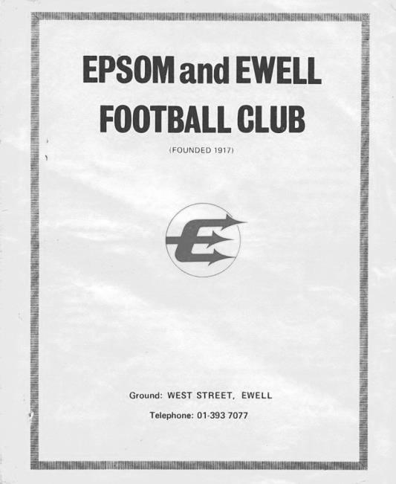
70 years ago today the war time Epsom Town club hosted the all-conquering Erith & Belvedere side and according to the papers, we were the better side, but just couldn’t find a way past the “invincible” Day in goal for the visitors. A single goal won it for the opposition.

40 years ago this week we faced Addlestone in the Quarter – Final of the F.A. Vase. The visitors were the new favourites for the competition, were two levels above us, and had been unbeaten in 21 matches before losing at Dulwich Hamlet the week before in the Surrey Senior Cup. Oh yes, and they had beaten us once already in that same competition, leading 4-0 at one point before we gave them a real scare by making the final score 4-3.

So Pat O’Connell would have already developed a fairly clear idea of what did and didn’t work against them and the plan worked well at West Street as goals from Tommy Tuite and Trevor Wales secured our passage to the Semi-Final. (see programme)

There was one moment of concern when centre-half Dave Worby collided with the referee and knocked him out. Worby then picked up the whistle and stopped play! The referee was ok but unable to finish the match which thankfully passed without further alarm for the 1,048 spectators.

31 years ago today we faced Banstead Athletic in the Surrey Senior Cup Quarter Final at a much different Merland Rise to the one we know today. There was no fencing around the ground and no cover apart from the main stand. All of that was paid for by our groundshare rent! Steve Hill, Malcolm Spratt and Robin Lewis ensured a comfortable passage to the Semi-Final where we would travel to play Croydon.

10 years ago this week we handed league leaders Hertford Town their first home league defeat of the season with a convincing 5-2 score line. The hosts weren’t helped by an early sending off for a professional foul as Chad Heuston was stopped from breaking through by a deliberate handball and we led by three goals at the half. Hertford pulled one back but we replied strongly and led 5-1 before Hertford scored a second in stoppage time.

6 years ago today our match at Camberley Town was abandoned after 57 minutes with the Krooners leading 2-1 due to a torrential downpour. When the game was replayed they still won 3-2!

3 years ago today we travelled to the Ranch for a League meeting with today’s opponents, winning comprehensively by three clear goals, the highlight of which was a stunning drive from the edge of the area by Carl Downs.

First Eleven Appearances - (max 36 inc Camberley Town)
Name | Debut | 2014/15 |  |  |  | Career Totals
 |  | App | Sub | Total | Goals | App | Sub | Total | Goals
BROWN Oshane* | 30/08/2014 | 2 | 0 | 2 | 0 | 2 | 0 | 2 | 0
BURNS Robbie | 14/08/2007 | 2 | 1 | 3 | 0 | 204 | 15 | 219 | 121
COOPER-SMITH Daryl | 03/01/2015 | 4 | 2 | 6 | 2 | 4 | 2 | 6 | 2
CURRIE Sam | 04/08/2012 | 4 | 3 | 7 | 0 | 98 | 8 | 106 | 2
DEAN Dan | 02/08/2014 | 27 | 1 | 28 | 0 | 27 | 1 | 28 | 0
DEWAR Ali | 29/10/2011 | 5 | 6 | 11 | 3 | 55 | 35 | 90 | 10
DOUGLIN Karl* | 03/08/2013 | 1 | 0 | 1 | 1 | 41 | 3 | 44 | 14
DOWNS Carl* | 17/09/2011 | 4 | 1 | 5 | 0 | 94 | 13 | 107 | 2
EACOTT Michael | 02/08/2014 | 34 | 0 | 34 | 0 | 34 | 0 | 34 | 0
FARRELL Matt | 02/08/2014 | 31 | 3 | 34 | 4 | 31 | 3 | 34 | 4
FERDINANDO Matt | 20/09/2014 | 19 | 3 | 22 | 6 | 19 | 3 | 22 | 6
GAFFNEY Luke* | 16/08/2014 | 10 | 1 | 11 | 0 | 10 | 1 | 11 | 0
HARPER Tommy* | 15/04/2014 | 1 | 0 | 1 | 0 | 2 | 1 | 3 | 0
HAYWARD Ben | 07/03/2007 | 6 | 0 | 6 | 0 | 242 | 28 | 270 | 18
HOADLEY Harry* | 27/08/2011 | 6 | 1 | 7 | 0 | 7 | 1 | 8 | 0
HOUGH Kyle | 14/08/2007 | 29 | 3 | 32 | 19 | 283 | 15 | 298 | 156
JARMAN Mark* | 08/08/2009 | 5 | 5 | 10 | 0 | 136 | 51 | 187 | 76
MARVELL Dale* | 15/01/2000 | 11 | 5 | 16 | 5 | 261 | 45 | 306 | 85
MCGREGOR Alex | 08/08/2009 | 13 | 1 | 14 | 1 | 170 | 55 | 225 | 27
MCKAY Alex | 20/12/2008 | 8 | 4 | 12 | 1 | 73 | 26 | 99 | 8
MURPHY George | 28/03/2013 | 22 | 1 | 23 | 1 | 63 | 5 | 68 | 3
MUTIMA Lionel* | 05/08/2014 | 4 | 2 | 6 | 0 | 4 | 2 | 6 | 0
NELMES Elliott* | 05/08/2014 | 2 | 0 | 2 | 0 | 2 | 0 | 2 | 0
PANAYI Anthony | 14/11/2010 | 28 | 1 | 29 | 0 | 155 | 15 | 170 | 4
PANAYIOUTOU Savva | 03/01/2015 | 5 | 0 | 5 | 1 | 5 | 0 | 5 | 1
ROBINSON Matt | 01/12/2012 | 17 | 1 | 18 | 3 | 18 | 4 | 22 | 4
ROBINSON Sam | 22/10/2011 | 20 | 1 | 21 | 6 | 44 | 4 | 48 | 11
ROWE Steve | 27/08/2011 | 10 | 0 | 10 | 0 | 15 | 1 | 16 | 0
SHAW Ollie | 20/09/2014 | 0 | 10 | 10 | 0 | 0 | 10 | 10 | 0
SMITH Matt | 08/08/2009 | 0 | 1 | 1 | 0 | 91 | 43 | 134 | 10
SMITH Taylor* | 02/08/2014 | 13 | 2 | 15 | 7 | 13 | 2 | 15 | 7
TANTON Matt | 02/08/2014 | 18 | 4 | 22 | 1 | 18 | 4 | 22 | 1
TAYLOR James | 26/08/2013 | 29 | 1 | 30 | 2 | 46 | 7 | 53 | 3
VAN GELDER Julian* | 12/09/2006 | 0 | 1 | 1 | 0 | 0 | 2 | 2 | 0
WHITE Sean* | 02/08/2014 | 6 | 13 | 19 | 3 | 6 | 13 | 19 | 3
Own Goal |  |  |  |  | 1
* Player has left the club

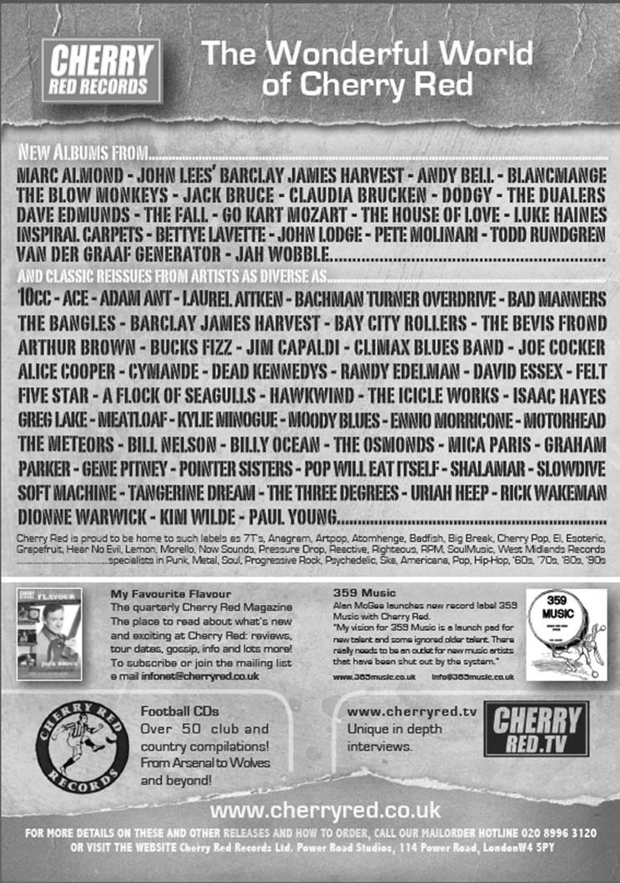
Centre page for results

Centre page for results

Cups – The latest position

EL Records Premier Challenge Cup
Quarter Finals
Colliers Wood Utd | V | Badshot Lea
Worcester Park | 21/3 | Windsor
Epsom & Ewell | 2-4 | Camberley Town
Farnham Town | 3/3 | Cove

Surrey Senior Cup
Quarter Finals
Ashford Town (Mx) | 3-1 | Westfield
Colliers Wood Utd | 0-2 | Merstham
Molesey | 3/3 | Badshot Lea
Met Police | 2-1 | Tooting & Mitcham
Semi Finals
Molesey / Badshot Lea | V | Met Police
Merstham | 10/3 | Ashford Town (Mx)

F.A. Vase
Quarter Finals – 28th February
AFC St Austell | 3-2 | Ascot United
South Western Peninsula |  | Hellenic
Erith & Belvedere | 0-2 | North Shields
Southern Counties East |  | Northern
Shaw Lane Aquaforce | 2-2+ | Glossop North End
Northern Counties East |  | North West Counties
Replay 7th March
Highworth Town | 1-1+ | Tadcaster Albion
Hellenic |  | Northern Counties East
Replay 7th March

Hanworth Villa F.C. – History
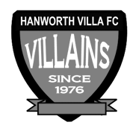
Hanworth Villa were formed in 1976 following a managerial disagreement at another long established Hanworth club. In the early years the team struggled in Division One of the Hounslow & District League, scoring a goal was usually celebrated with a public holiday. During the close season and following hard work by Jimmy Connors, who rebuilt the team, they finished Division One Champions.

The following season saw the club start an incredible run in the league, which finished 68 matches later, with 'The Villains' winning the Hounslow Premier League, and the West Middlesex Division One and Two Championships. The success continued with Hanworth being elected to the newly formed Middlesex County Football League.

From 1980 the club had a nomadic existence but in 1997 moved to its existing Headquarters at Rectory Meadow. This move led to the formation of Hanworth Villa Sunday, and later a reserve team, being an amalgamation of teams from - The Sawyers Arms, The Queen Dowager, and Feltham Railway Club, not that the lads like the odd beer! A Chiswick League double in 1993 and a 19-0 Cup Final victory in the National Railways Cup (did the opposition run out of steam?) cemented the successful amalgamation.

Following hard work by Dave Brown the club was granted a lease at Rectory Meadow. At last we had a permanent home and could set about converting an existing pavilion into a clubhouse, which has become known locally as “The Ranch”. With a permanent base we were able to concentrate on improving our football, and recent years have seen all our teams win numerous trophies, the most notable performance being by our Sat 1st team who landed “the treble” in 02/03, winning the Middlesex County Premier league, the Open Cup and the League Cup. After another premier league title in 2004/05, this time with a record number of points, it was decided that it was time to move on and the club were elected to Division One of the Combined Counties League in time for the start of the 05/06 campaign.

The Combined Counties Experience
It took a while to adapt to the new level of football, but in our second season we managed to win the Challenge cup. The following season, 2007/08, we successfully managed to defend the Challenge Cup and narrowly missed out on the league title, finishing a creditable second; our facilities however, prevented our promotion into the Premier Division. The club were determined to ensure that that situation wouldn’t arise again, and, with typical determination, the committee managed to raise the funds to ensure that floodlights and a spectator stand were installed in time for the start of the 08/09 campaign. The effort wasn’t in vain as we once again finished second in what was a very tight end to the season with the top 5 sides being separated by just 3 points. After a successful ground inspection we were promoted to the CCFL Premier in time for the 2009/10 season.

Our debut season in the Premier proved to be as difficult as we expected. Points were few and far between for the first half of the season, but we gradually started to come to terms with the improvement in standard required, and we managed to put together performances worthy of a CCFL Premier side. By the end of the season we had obtained enough points to finish in 17th position, 3 clear of the relegation places.

That 1st season taught us a lot and changes put in place during the close season allowed us to have a more comfortable second season, in which, we not only finished a creditable 5th in the league, but also reached the finals of the Middlesex Senior Charity Cup and also, for the 2nd consecutive season, the Southern Combination Cup. Unfortunately we lost out by the odd goal in both finals.

2012/13 saw us finish 3rd in the CC FL our highest ever position in the football pyramid since we were formed in 1976. There was also a very creditable run in both the FA Cup and Vas competitions. In the FA Cup we just lost out to AFC Totton 3-2 missing our on a first round proper tie with Bradford Park Avenue. Our run in the FA Cup saw wins over Shrivenham, Bedfont Sports, Wembley, Aveley and Slough Town. In the FA Vase we lost out to Herne Bay one of the beaten semi-finalists at the third round stage.

The 2013/14 season contained a top ten finish and another good F.A. Vase run.

Club Statistical History - (including Camberley Town match on 24/02/15):
League: Played: 2,782, Won: 1,132, Drawn: 527, Lost: 1,123
For: 5,097, Against: 4,969, GD: plus 128 - Win Ratio 40.69%

CCL only: Played: 361, Won: 158, Drawn: 69, Lost: 134
For: 631, Against: 583, GD: plus 48 - Win Ratio 43.77%

Cup and Other: Played: 1,092, Won: 518, Drawn: 127, Lost: 439
For: 2,374, Against: 2,038, GD: plus 336 - Win Ratio 47.44%

Abandoned Matches: Played: 8: For: 14, Against: 16

Under Glyn Mandeville: Played 26, Won: 12, Drawn: 0, Lost: 14
For: 50, Against: 55, GD: minus 5 - Win Ratio 46.15%

Total: Played 3,874, Won: 1,650, Drawn: 654, Lost: 1,562, Aban: 8
For: 7,471, Against: 7,007, GD: plus 464 - Win Ratio 42.59%

First Senior Match: 30th August 1924.
Lost 1-3 vs Dorking at our home ground at the time of Horton Hospital Grounds.

First Match Programme Issued: 15th September 1923.
Won 4-0 vs West Norwood Reserves - Friendly match at Horton Hospital Grounds.

Number of Official Home Grounds: Six.

Alexandra Recreation Ground 1918-1922,
Horton Hospital Grounds 1922-1925,
West Street 1925-1993,
Merland Rise 1993-2010,
Moatside 2010-2012,
High Road 2012- present.

Record Win: 12/10/1935. 13-1 v Reigate Priory (H) - Amateur Cup.

Record Defeat: 14/02/1948. 0-14 v Chelmsford City Reserves (A) - London League.

Longest Serving Manager: 1) Adrian Hill 853 1982-1985 & 1990-2003
2) Pat O’Connell 466 1973-1982
3) Lyndon Buckwell 407 2006-2014
4) Ricky Kidd 190 1986-1990

Record Appearances: 1) Graham Morris 658 1990-2004
2) Nigel Bennett 630 1989-2005
3) Tommy Tuite 582 1973-1987
4) Ernie Watkins 419 1945-1960

Record Goal Scorers: 1) Tommy Tuite 391 1973-1987
2) Reg Marlow 254 1924-1936
3) Jimmy Jones 148 1933-1945
4) Kyle Hough 137 2007-present

Most Appearances in a season: Tony Coombe and Tommy Tuite - 59 in 1980/81.

Most goals in a season: Reg Marlow - 65 (at least) in 39 appearances in 1926/27.

Senior League Titles: 5 - 1925/26 Surrey Senior League - 1926/27 Surrey Senior League - 1927/28 London League - 1974/75 Surrey Senior League - 1977/78 Isthmian League Division Two

Player Sponsorship
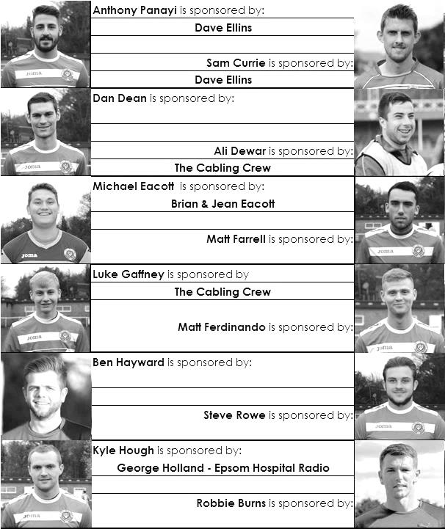

Here is the latest list showing all of the players and Management available for sponsorship. Sponsorship costs just £40 so if you want to help the club, the player and get your name in the programme for the season, let us know before they go!

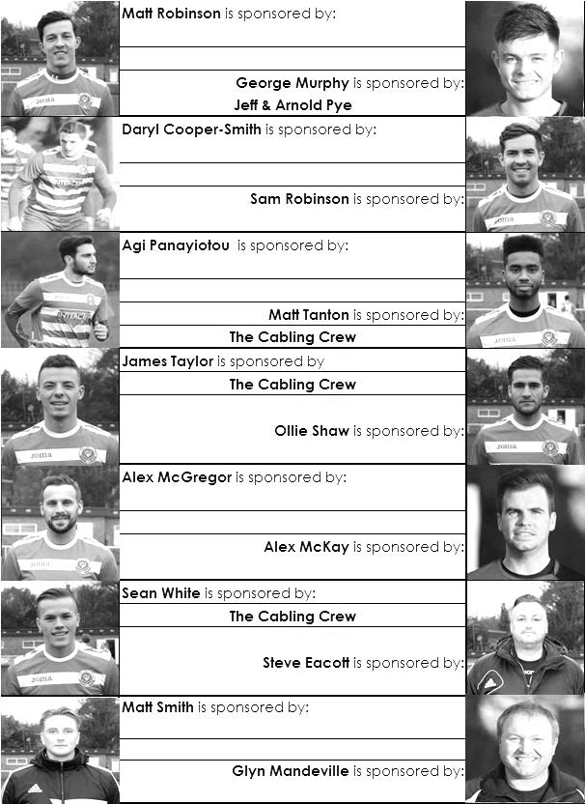

Match and Ball Sponsorships – 2014/15
Opponent | Date | Match Sponsor | Ball Sponsor
Raynes Park Vale | 05/08/14 | Club President - Stella Lamont
Horley Town | 25/08/14 | EEFC Management Committee
Croydon (FAC) | 30/08/14 | EEFC Media Officer - Richard Lambert
Frimley Green | 13/09/14 | Dave Gaffney and friends
Guildford City | 30/09/14 | The Jarman family
Mole Valley SCR | 07/10/14 | Mark and Carmel Murphy
Bedfont Sports | 11/10/14 | Epsom & Ewell F.C. Colts
Knaphill (LC) | 14/10/14 | Geoff and Steve Dyke
Ashford Town (Mx) | 18/10/14 | The Building Shop, Bookham
Chertsey Town | 28/10/14 | In Memory of Bob Bexley
Molesey | 22/11/14 | The Cabling Crew 0208 -224 4110
Camberley Town (SSC) | 02/12/14 | In memory of Liz and Doug Burns
Spelthorne Sports | 16/12/14 | long serving supporter Paul Merritt
Windsor | 03/01/15 | Ezara Beddoe
Farnham Town | 17/01/15 | In memory of Chris Henry
Camberley Town | 07/02/15 | Former player Marvin Hough
Hartley Wintney | 21/02/15 | Steve and Geoff Dyke
Camberley Town (LC) | 24/02/15 | Epsom & Ewell Colts FC
Hanworth Villa | 03/03/15
Cove | 07/03/15
Badshot Lea | 21/03/15
Westfield | 24/03/15
Colliers Wood United | 04/04/15 | Nathan Lambert
Knaphill | 18/04/15
For League, League Cup and Surrey Senior Cup Matches:

Match sponsorship - £40.00 Match ball sponsorship - £25.00.
Combined Offer of Match and Match Ball sponsorship for £55.00.

For F.A. Cup and F.A. Vase matches:

Match sponsorship - £50.00 Match ball sponsorship - £30.00.
Combined Offer of Match and Match Ball sponsorship for £65.00.
----------------------------------------------------------------------------------------------------------------------------
Sponsorship includes: (x2 for match, x3 for match and ball)

Admission, programmes, hospitality and advertising and mascot for the day (if required).

If you are interested, just speak to a Committee Member, you know where we are!
Alternatively, drop me an email at: richard.c.lambert@gmail.com

Salts Super Six Predictor
The Salts Super Six Predictor is live again. The next matches are TODAY and tickets are on sale at today’s game to the left of the gate.

The competition is easy to play and you don’t even have to be at the match! To win, you simply need to predict the results of six matches correctly from the three options, fill in the form and make sure it is back with one of our distributors before the deadline on the ticket. The latest fixtures are shown here.

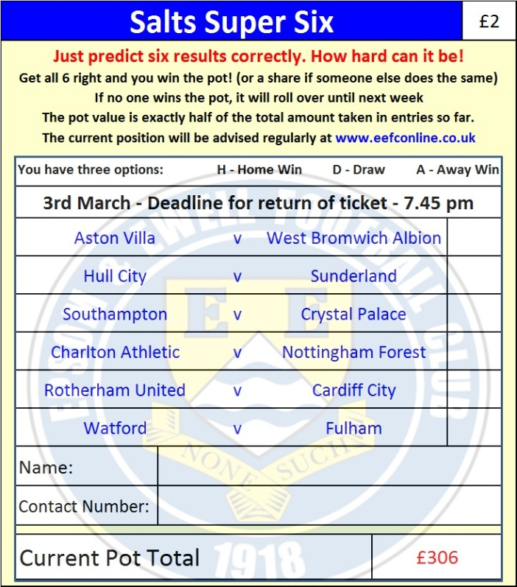
If you are a club regular, you just need to place your name on the sheet, although if you aren’t, then we’ll need a contact number from you too. We will announce any winners on the website within three working days, so don’t worry, we won’t miss you!

The prize pot is currently £306 but will continue to go up, if unclaimed, by the cost of 50% of all the sold tickets. In other words, if we sell 50 tickets at £2 before the deadline, and the pot isn’t won, then the next prize would be £356! You’ll always know the size of the pot before you enter.

Please note that if there is more than one winner, the prize pot would be shared between the winners. All you need to do now is have a go, as many times as you like!

Good luck!

Combined Counties League – Premier Division
Tuesday, 3rd March 2015 - Kick-off 7.45 p.m.
Epsom and Ewell  (Royal Blue & White hoops) | V |  | Hanworth Villa  (Red and White / Black / Black)
 | NUMBERS
Michael Eacott |  |  | Dane Buss
James Taylor |  |  | Jamie Miles
Steve Rowe |  |  | Tony Buss
Anthony Panayi |  |  | Adam Baigent
© Sam Currie |  |  | Matt Baines
Dan Dean |  |  | Elliot Frost ©
Matt Ferdinando |  |  | Steven Loveridge
Matt Farrell |  |  | Ross Cheetham
Kyle Hough |  |  | Dale Marvell
Sam Robinson |  |  | Jimmy Major
Alex McGregor |  |  | Adam Willis
Daryl Cooper-Smith |  |  | Matt Grave
Alex McKay |  |  | Tom Dilloway
Matt Robinson |  |  | Josh Hughes
Matt Tanton |  |  | Ade Oshilaja
Savva ‘Agi’ Panayiotou |  |  | Luke Muldowney
George Murphy |  |  | Reece Jackson
Ali Dewar |  |  | Mayulu Katutondua
Robbie Burns
Ben Hayward
Glyn Mandeville | MANAGER |  | W.Noad
Matt Smith | ASSISTANT |  | A.Willis
Steve Eacott / Alex McKay | COACHES
Ken Jones | PHYSIO |  | D.Ravenscroft
REFEREE: A.Jallow (Woking)
ASSISTANTS: K.Corrick (Oxted), R.Van Niekerk (Sutton)

OUR NEXT VISITORS TO HIGH ROAD
Cove
Saturday 7th March 2015 - Kick-off 3.00 p.m.
Combined Counties League – Premier Division

